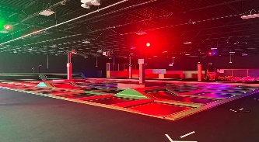
NovaTrampoline Park
Field Trip Details |  | What to bring  Packed lunch and drink labeled on the outside with your child’s name.  Nova socks must be worn in order to use the facility. The price of the socks is included.  Note: No cell phones or other electronic devices are allowed on this field trip. Any equipment of this kind will be taken away by the staff and returned at the end of the day.  Nova Trampoline Park requires each child to have a signed waiver, can be found on our website when registering. Please sign and return the waiver:
Location | Nova Trampoline Park (Plymouth)
Dates | Wednesday June 26, 2024
Time | 10:00am-2:00pm
Transportation | School Bus
Cost | $46.00
 | Your child must be in attendance no later than 8:30 AM. wearing a Pembroke Recreation T-shirt.

Nova Trampoline Park

I give permission for my child/children, ___________________________ to attend the field trip to Nova. I understand that Pembroke Recreation does not carry insurance on participants and assumes no liability for injuries sustained while participating in our program. Summer Happenings participants participate in a number of off-site field trips and the parent or guardian signing this release recognizes and understands that injuries can occur while participating and can be an inherent and unavoidable consequence of some activities. Having read this disclaimer I hereby approve my son’s/ daughter’s participation the Summer Happenings program and agree to hold Pembroke Recreation, its commissioners, counselors, directors, and managers harmless from any and all actions, claims and damages for personal injuries and disabilities that I and or my child/children may sustain or incur as a result of participation in this program.

Parent / Guardian’s Signature _____________________________________Date_____/_____/_____

